Challenged:Đinh Hoàng Sáng

ID:BEBEIU17022

Result:

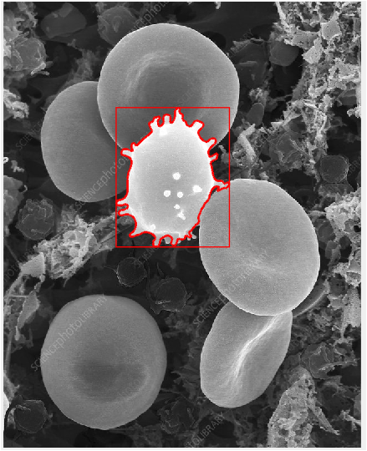

Code:

clc

close all

clear all

%%Auto clear

I = imread('800wm.jpg');

%Show original image

figure,imshow(I),impixelinfo

%%grayscale

gray=rgb2gray(I);

%Show index

figure,imshow(gray),impixelinfo

%%Injust image

g3 = imadjust(gray,[0.5 0.75],[0 1],3);

figure,imshow(g3),impixelinfo

%%grayscale->Binary

g = imbinarize(g3);

%%fill up

BWdfill = imfill(g, 'holes');

figure, imshow(BWdfill)

%denoise

g = bwareaopen(g,3000);

figure,imshow(g)

%fill up

BWdfill = imfill(g, 'holes');

figure, imshow(BWdfill),impixelinfo

%smooth(denoise)

seD = strel('diamond',1);

BWdfill = imerode(BWdfill,seD);

BWfinal = imerode(BWdfill,seD);

figure, imshow(BWdfill),

%rgb = label2rgb(BWdfill,'jet',[.5 .5 .5]);

%figure,imshow(rgb)

%%Denoise by watershed()

D = bwdist(~BWdfill);

figure,imshow(D,[])

%

D = -D;

figure,imshow(D,[])

%

L = watershed(D);

L(~BWdfill) = 0;

%

figure,imshow(L),impixelinfo

%%Denoise

L = imbinarize(L);

figure,imshow(L),impixelinfo

%%Mask

[r c] =size(BWdfill);

for i = 1:r

for j= 1:c

if L(i,j) == 1

BWdfill(i,j) = 0;

end

end

end

%

figure,imshow(BWdfill),impixelinfo

%%denoise again

g = bwareaopen(BWdfill,1000);

figure,imshow(g)

%%Expand

se90 = strel('line', 3, 90);

se0 = strel('line', 3, 0);

%

g = imdilate(g, [se90 se0]);

figure, imshow(g)

%%draw cover

figure,imshow(I)

[B,L] = bwboundaries(g,'noholes');

hold on;

for i = 1:length(B)

boundary =B{i};

plot(boundary(:,2), boundary(:,1),'r','LineWidth',2)

end

%draw boundingbox

hold on;

statsB = regionprops(L,'BoundingBox');

for k = 1 : length(statsB)

BB = statsB(k).BoundingBox;

rectangle('Position', [BB(1),BB(2),BB(3),BB(4)],...

'EdgeColor','r','LineWidth',1 )

end